**Making a Pavement Licensing Application**

**Introduction**

This short guidance document is to assist businesses making an application for a pavement licence.

A pavement licence authorises the use of tables, chairs and other furniture for the consumption of food and drink in connection with a business such as a restaurant, café, bar or pub.

A pavement licence cannot be used to authorise any other objects on the highway.

**Land that can be used**

Only relevant highway can be used for tables and chairs. Relevant Highway has a legal definition but in essence it means an area where the public ordinarily have the right to pass along that land.

Before making an application or deciding that one is not needed, you should ensure that the area you wish to use is “relevant highway”.

**Privately owned land**

If the land is privately owned you do not need a pavement licence but will need the consent of the land owner.

**Land not “relevant” highway**

Some land may be “public” but not “relevant”. For instance highway verges, parks etc. A licence cannot be granted for such an area.

**Unsure if land is relevant highway?**

Before putting tables and chairs on any land you should establish whether or not you need a licence or any other consent. You do not need a pavement licence to put furniture on land you own, however, you will be able to expect to prove to the council that the land is yours.

**Requesting a Land Registry Check**

The Council can check the ownership of a piece of land on your behalf for a fee of £10. We can then confirm whether or not you are exempt from needing a pavement licence. You may also be able to check the land yourself via the [www.landregistry.gov.uk](http://www.landregistry.gov.uk) site for less or reference to your own title deeds.

**No Obstruction condition**

A statutory condition will be placed on the licence require that there be no obstruction to the public highway. If your proposed usage of the area amounts to the obstruction of the highway a licence will not be granted. In order for there to be no obstruction the area utilised for a pavement licence must leave a specific amount of space.

**2 metre space must be left**

You can apply to occupy as much of the public highway as you wish provided that there is sufficient room left for the public to pass by. The amount of space that must be left should be 2 metres. This is measured from the edge of your proposed licensed area and the edge of the public footpath.

An example is below. The red rectangle is the pavement licence area of a restaurant (the blue box). The green line is the measurement between the pavement licence area and the road. This measurement is 2 metres.

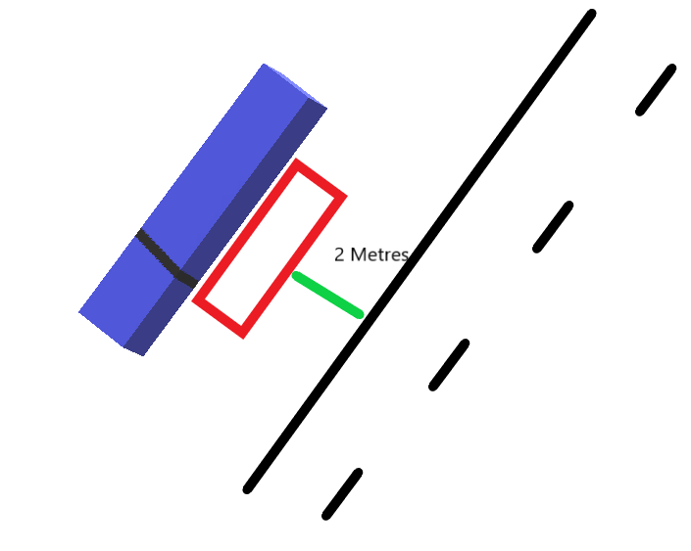

Even if 2 metres space can be left the Council may not approve the large scale occupation of the public highway if it is unreasonable. The Council will have regard to the needs of the public and the reasonableness of the usage by the business.

**When less than 2 metres may be acceptable**

The Council expects that a 2 metre gap is provided where it can be accommodated. Where 2 metres is not possible the Council may accept a lesser distance – but no smaller than 1.5 metres.

The Council’s policy sets out when this may be acceptable. For instance, if there is street furniture placed by the Council that has an impact on the distance or if the distance that is less than 2 metres is only for a small part of the area left unoccupied by the business and the majority of space left is 2 metres or more.

You will need to provide clear measurements of this on the plan that you submit to us.

**Application**

If you are satisfied that the land is relevant highway or the Council has confirmed that it is you should submit the application form to us.

You will need to submit the following to us:

|  |  |
| --- | --- |
| **Plan of the area to be used** | 🞎 |
| **Photographs of furniture or brochure.** | 🞎 |
| **Public liability insurance up to a value of £5million.** | 🞎 |

The plan will need to be to scale and include accurate measurements showing the amount of highway you intend to use and the space available for the public to use.

In addition you will need to complete the statements of compliance on the application form and should submit to us any risk assessments you have separately completed. You must consider the health and safety implications of your proposal and the needs of those with a disability.

Failure to consider such matters may result in the rejection of your application or a delay.

You will also need to pay the fee of £300 which can be paid here: [Civica Payments Portal - Products & Services - Pavement License | E0000215 false (civicaepay.co.uk)](https://www.civicaepay.co.uk/HertsmereEstore/estore/default/Catalog/Index?catalogueItemReference=E0000215&showSingleProduct=True&recurringOnly=False)

**Consultation**

A 14 day consultation period starts the day after a valid application has been received if you are satisfied that the application you have submitted is valid you can display the notice the following day. A template notice is available.

You may however choose to wait and request that the Council verify that your application is valid. Please note that if you wait for the Council to verify your application and provide you with a copy of the notice to display the process might take longer than if you do this yourself. The Council expects to verify applications within 2 working days and in busy periods this could be 5 working days. However, if you submit an application that is invalid, the application will need to be resubmitted.

**Decision**

The Council must determine the application within 14 days of it being valid. If we do not the licence is automatically granted.

The Council may decide either to approve your application and grant the licence or refuse the application. There is no right of appeal to a decision to refuse but you may apply again.