**Hertsmere Borough Council**

**2025/26 DRAFT BUDGET SUMMARY**



**Background**

At its meeting on 15 January 2025 our Cabinet considered the draft revenue budget for the next financial year (2025/26) and recommended this budget for consultation before we present the final budget to a meeting of the Full Council for approval on 26 February 2025. As a key stakeholder we would like to seek your views on our budget proposals.

This document provides a summary of some of the key elements of our draft revenue budget for 2025/26. The detailed draft revenue budget report can be found on the 15 January 2025 Cabinet agenda pages of our website via the following link: [Agenda for Cabinet on Wednesday, 15 January 2025, 6.00 pm](https://hertsmere.moderngov.co.uk/ieListDocuments.aspx?CId=565&MId=11839&Ver=4)

**Setting the 2025/26 revenue budget**

The 2025/26 revenue budget has been set under challenging economic conditions. Whilst the economy has been recovering, economic growth has been slower than had been forecast and this was reflected in the Chancellor’s Autumn Budget statement. We have seen interest rates start to fall and whilst Consumer Price Index (CPI) inflation had fallen to 1.7% in September, slowing down the impact on the cost of living, CPI has risen again over the past few months reflecting market uncertainty. The prolonged period of high interest rates and high inflation continue to have an impact on household budgets affecting our residents and staff, with price inflation also continuing to put pressure on our budgets.

When setting the 2025/26 budget we have therefore considered many factors. Some of the main considerations are:

* **Government funding and policy** – the provisional finance settlement announced in late December 2024 provided details on 2025/26 government funding, policy and referendum limits set for Council Tax increases. Hertsmere’s financial settlement was challenging with our core Government grant funding remaining at current levels, without any inflationary increase. The increase in employer’s National Insurance (NI) contributions also present a significant risk and we await confirmation of additional government funding.
* **Economy and Cost of Living** – the overall economic climate and the cost of living has a potential impact on service costs and the ability to generate income through fees and charges.
* **Recruitment and Retention –** the current labour market has become extremely challenging and continues to have a detrimental impact on services, such as waste management and civil enforcement, but has also impacted other service areas such as planning.
* **Income** – whilst budgeted income from rent, sales, fees and charges is set to rise from £17.7m in 2024/25 to £20.1m in 2025/26, the majority of income budgets are subject to external factors, such as supply and demand, market forces and the general state of the economy and competitiveness of the market.
* **Council Tax** – in line with Government funding policy this draft budget proposes a Council Tax increase of 2.99% equivalent to £6.10 for the year 2025/26 for an average band D property.

**Balancing the budget**

Setting a **“Balanced Budget”** for the year ahead is a **Statutory Requirement** for us. A balanced budget is where our **“Net Budget Requirement”** is matched by an equivalent level of funding.

Our **gross expenditure budget for 2025/26 amounts to £62.1m** of which £26.0m relates to housing benefit payments. Housing benefit payments are in the main funded by the Department for Work and Pensions through the housing benefit subsidy grant. Our **gross income budget is £48.3m** inclusive of the housing benefit subsidy. These budgets include all frontline and corporate costs.

We are budgeting to raise around £22.3m a year through income generation, the majority of which comes from rental income from our property portfolio. We also raise income through fees and charges for some specific services and we also receive some specific grants as well as contributions from third parties. Our commercial approach to income generation has helped us to protect our frontline services over a period of reducing funding, significant cost increases and rising service demand. Since 2011, our income has been rising year on year and in total by around 145% or £13.2m over the past 15 years, as shown in Chart 1 below:

**Chart 1 – Income Generation 2011/12 to 2025/26**

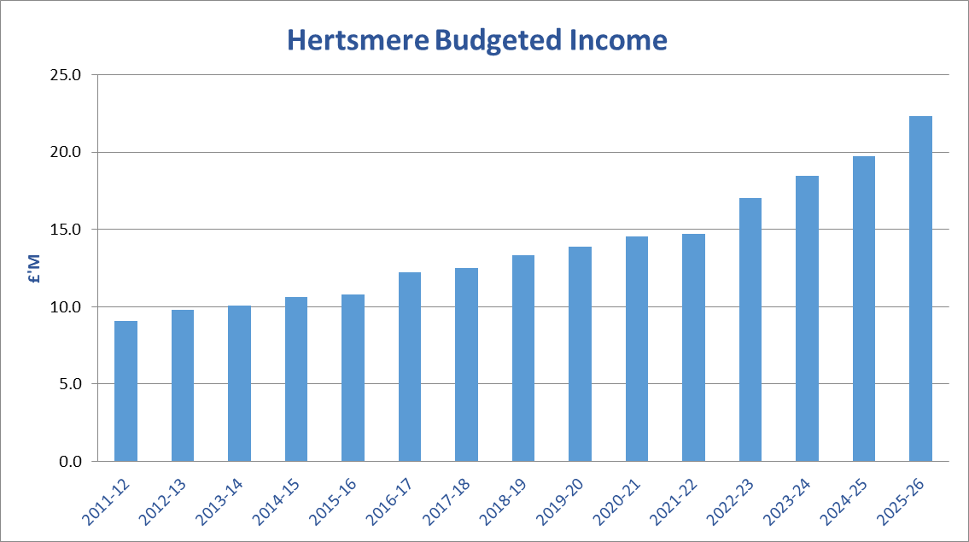

When the 2025/26 draft budget was presented to the Cabinet, at that time it showed a net funding gap of £0.6m whereby core funding of £13.8m did not meet the Council’s spending requirement of £14.4m. The Cabinet were however also presented with options for meeting this funding gap and agreed the recommended options to utilise the additional Homelessness Prevention Grant funding (£0.4m) and some of the new Extended Producer Responsibility levy (£0.2m). As these funding sources fall outside of core funding they are now reflected within the related service budgets which means that **the Council’s net budget requirement for 2025/26 is now £13.8m,** which is our total gross spend on services less any income raised from those services.

**Draft budget 2025/26**

The draft budget for 2025/26 as set out below shows the gross budgeted expenditure and income by service area (inclusive of housing benefit) and amounting to a net service budget requirement of £13.8m. The corporate budgets, which are held separately, include a central contingency budget, audit fees and banking charges and general expenditure as well as budgets that are yet to be allocated to specific services, including a proposed staff pay award for 2025/26 of 3%, which is still subject to approval.

This results in a total **Net Budget Requirement** **of £13.8m**, which is financed partly from government grant funding totalling £4.7m or 34.2% with the remaining £9.1m or 65.8% of our funding coming from local Council Tax levies.

The draft budget does not however include the additional costs of employers NI announced by the Chancellor in her Autumn budget which she also stated would be fully funded for public services. We await funding confirmation.



**Government funding**

Around **£4.7m of the 2025/26 net budget requirement is funded by core government grants** which are based on the Government’s assessment of need and our ability to raise tax locally. This is made up of **£3.6m from Business Rates**, collected locally but distributed nationally. Currently we collect around £65m in business rates per annum and pay the majority of this over to Central Government by way of a tariff which is then redistributed nationally via the Government’s national funding formula.

**We will receive a further £1.1m through other core government grants** including £0.2m from the Revenue Support Grant (RSG), New Homes Bonus (NHB) and the Domestic Abuse Safe Accommodation grant. The remaining £0.9m will be received through the funding floor, a mechanism introduced in 2023/24 to guarantee that all local authorities would receive a minimum uplift in their Core Spending Power. For 2024/25 the funding guarantee was 4% however for 2025/26 the floor has been set at zero which has meant our core spending power has not increased for next year.

Our core government grant funding now represents around 34.2% of our net budget requirement which is a reduction compared to 2024/25 at 36.2%. Whilst core government funding had stabilised over the past few years following the end of austerity, a period during which we had seen a significant reduction in our general government grant funding, the change in the funding floor mechanism for this year has resulted in a real terms funding reduction.

Back in 2011/12, general government funding accounted for around 50% of our total funding compared to 34% for 2025/26, which means that the cost of providing our services has fallen increasingly on council taxpayers. In 2025/26, 66% of our net budget requirement will now be funded from local Council Tax levies compared to just 50% in 2011/12. The movement in funding is shown in Chart 2 below:

**Chart 2 – Change in funding 2011/12 to 2025/26**

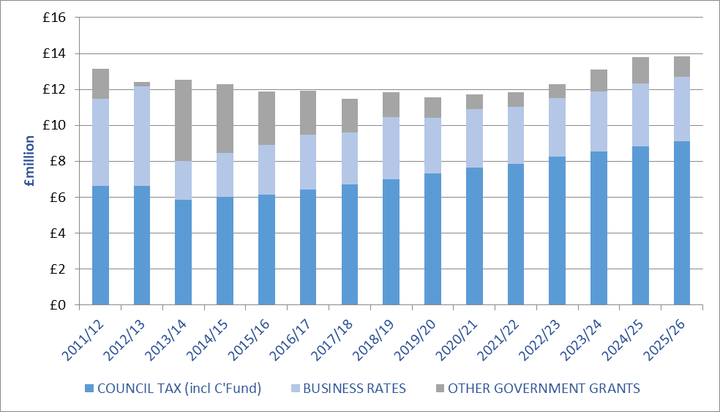

**Council tax**

Although you pay all of your council tax to us at Hertsmere Borough Council, the share that we keep is just nine per cent. The majority share, 77%, goes to Hertfordshire County Council; the police receive 12% and the parish and town councils two per cent. The county council and the police are responsible for setting their own council tax.

For the coming year, we are proposing to **increase our share of the council tax bill by 2.99 per cent equivalent to £6.10 which is a rise of around 12p per week per household**. This increase, which is proposed be recommended to a meeting of the full Council on 26 February 2025, will see our share of the **average council tax for 2025/26 set at £210.06**, the equivalent of **just 58p per day**, for an average band D property in the borough.

Every day we provide services across the borough such as kerbside rubbish and recycling collections, housing, environmental health, local planning, car parking, leisure, culture and parks and grant funding to the charity and voluntary sector including support for Citizens Advice. Your council tax is just one of the sources of income that helps to pay for these valuable services.

Whilst we work hard to improve the cost effectiveness of the services we deliver as well as manage the increasing demand as our population continues to grow, in light of high inflation and rising costs, changes in service demand and continued funding uncertainty, the increase has been necessary to maintain the provision of front line services.

An increase in council tax of up to three per cent or £5, whichever is greater, is allowed by legislation and is the amount that the Government has assumed in its spending forecasts for Local Government.



**What’s next?**

Whilst we are now presenting a balanced budget position for 2025/26 we must also look to the medium term to identify our future budget requirements and how these are funded. The Council’s medium term financial plan therefore looks forward to 2028/29 and based on our current budget and funding assumptions we are forecasting a funding gap over the medium term of £0.7m.

Whilst the provisional finance settlement, announced in late December 2024 included funding allocations for next year only, the seventh successive one year settlement, the Chancellor did also announce in her Autumn Statement that the Government intended to bring forward the long-awaited Local Government funding reforms ahead of the next financial settlement which will include multi-year settlements for local authorities, thereby improving funding certainty. The “Fair Funding Review” will include a review of relative needs and resources nationally and will likely see a reset of the Business Rates baseline funding which may well see locally retained business rates growth being redistributed under the national formula.

We continue to face uncertainty with our own income streams, as these are dependent on various external drivers in particular the economy and the impact locally on levels of employment, business growth and demand for services such as homelessness and affordable housing.

Therefore, given the significant financial pressures and the statutory requirement to set a balanced budget, whilst at the same time preserving as far as possible the current level of services, we are continuing to look at innovative ways of managing the funding pressures over the medium term.

Over a number of years we have adopted a more entrepreneurial approach and focused on expanding our ability to generate income as well as reducing costs by entering into partnerships with other councils, to share expertise and build resilience, as well as looking for commercial opportunities such as establishing our own subsidiaries, Elstree Film Studios and Hertsmere Developments Limited. We also currently have partnerships with other local authorities for building control, CCTV, audit and anti-Fraud to name a few.

In light of the current uncertain economic conditions and other pressures on the budget, going forward, Hertsmere is aspiring to achieve financial self-sustainability. The ability to raise additional income however continues to be extremely challenging due to statutory fees and other restrictions on charging limiting Hertsmere’s ability to raise additional income from fees and charges. Hertsmere needs to continue its innovative and commercial approach over the coming year and will be looking at how we can leverage the maximum return from our assets.

**Have your say**

If you would like to comment on the 2025/26 draft revenue budget please take part in our budget consultation by no later than 16 February 2025 to allow your comments to be considered in the final budget papers. Here is the link to the consultation: [Budget Consultation 2025/26 - Hertsmere Borough Council](https://www.hertsmere.gov.uk/your-council/budget-consultation)